12 сентября - ViewModel и состояние в Compose

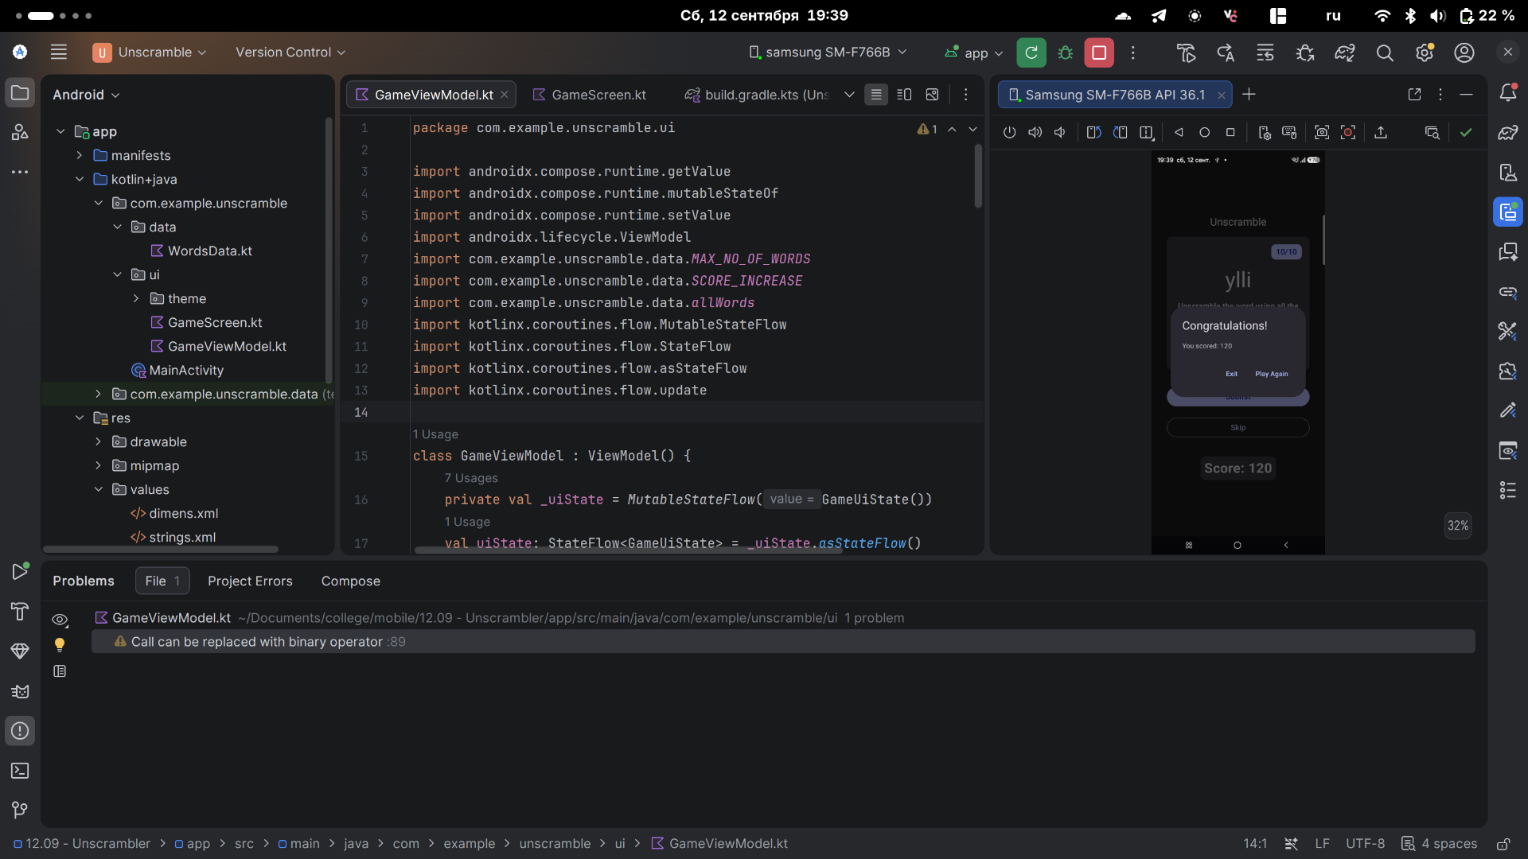

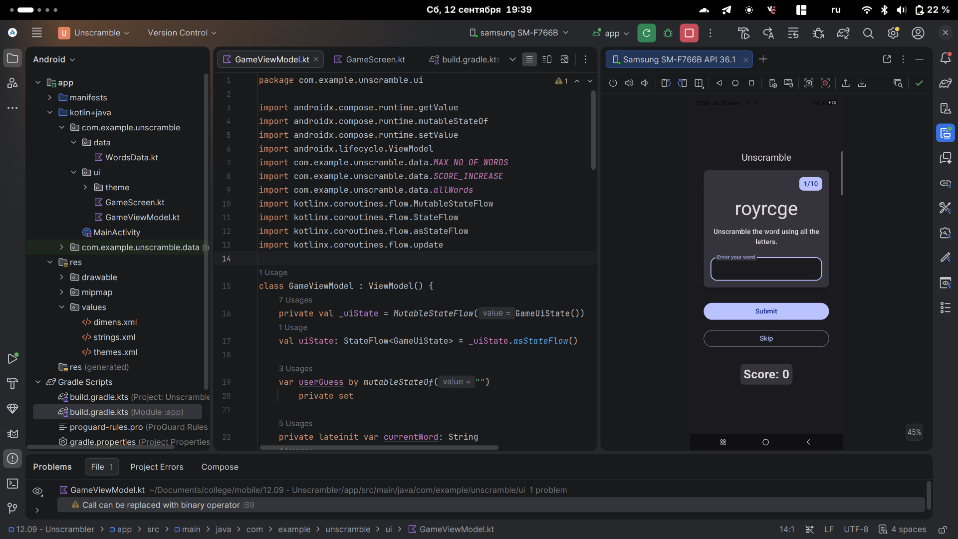

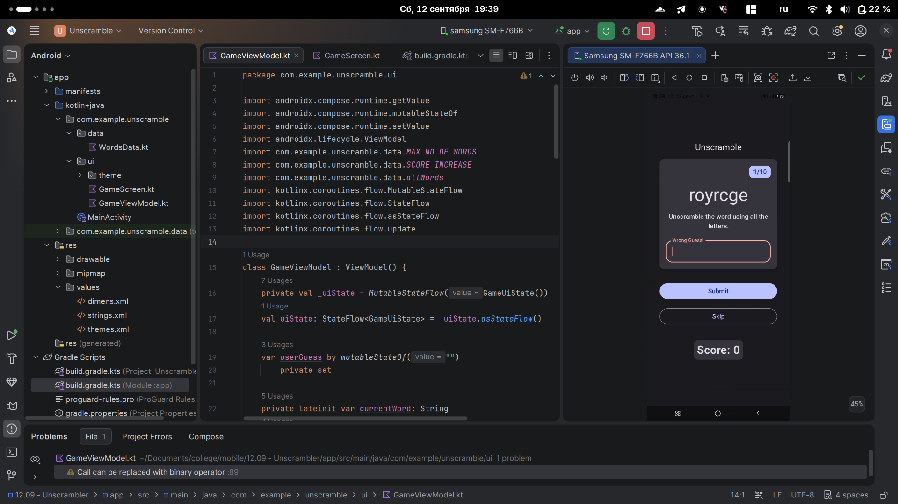
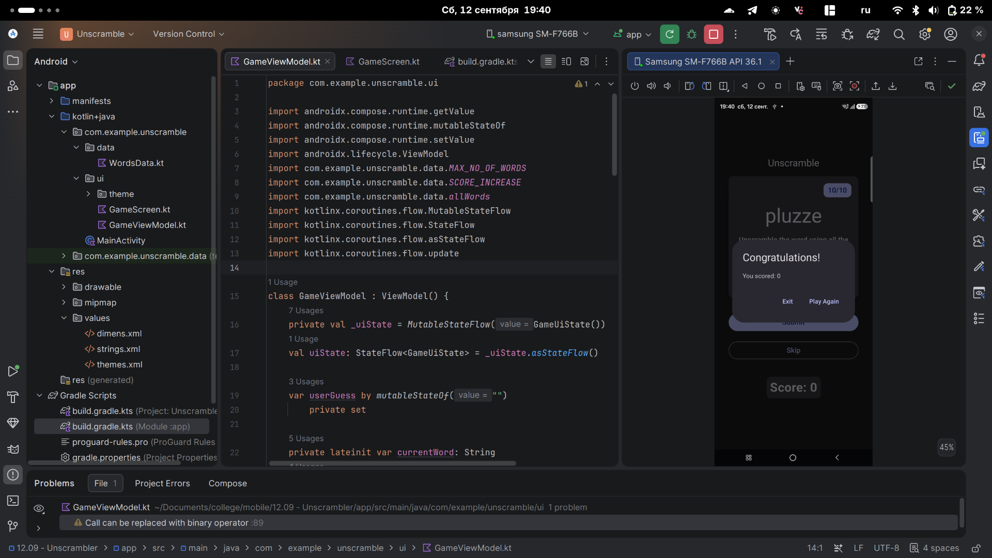
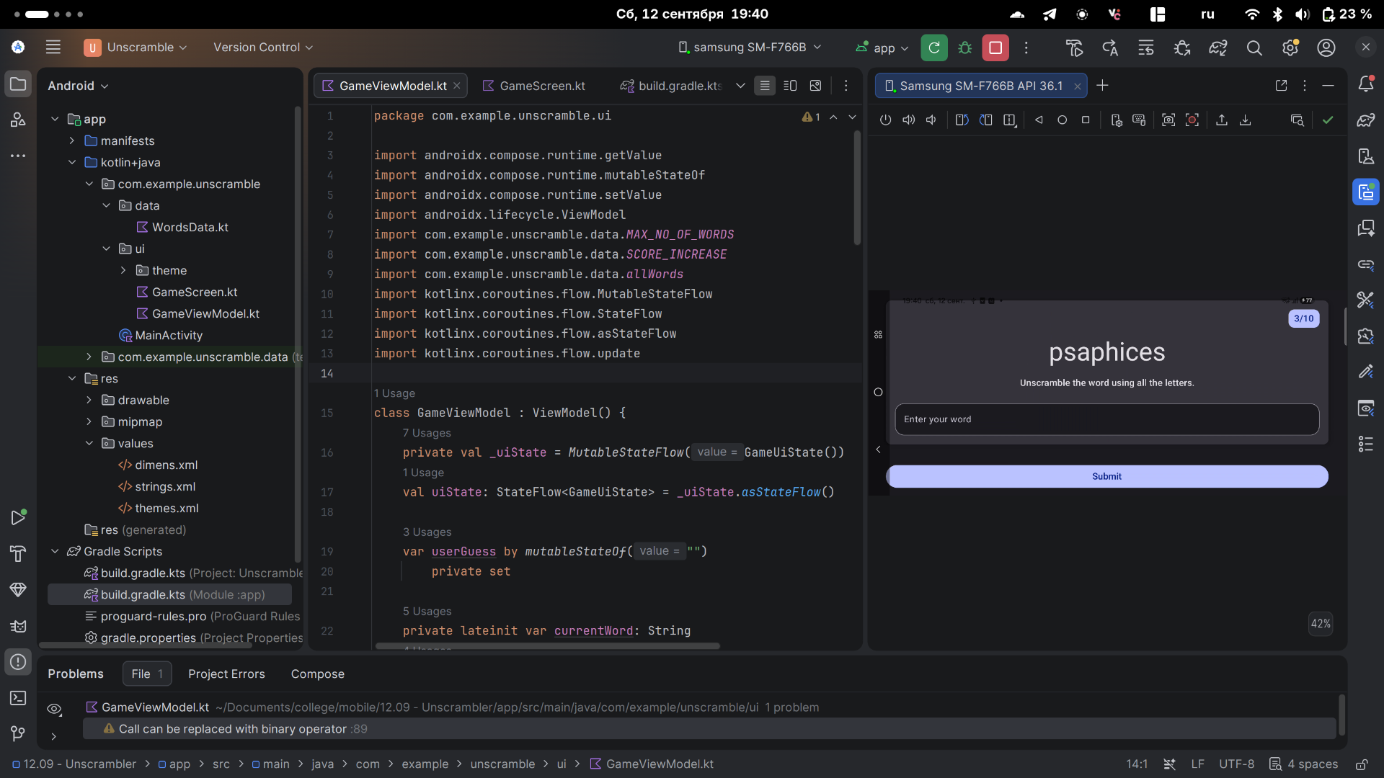
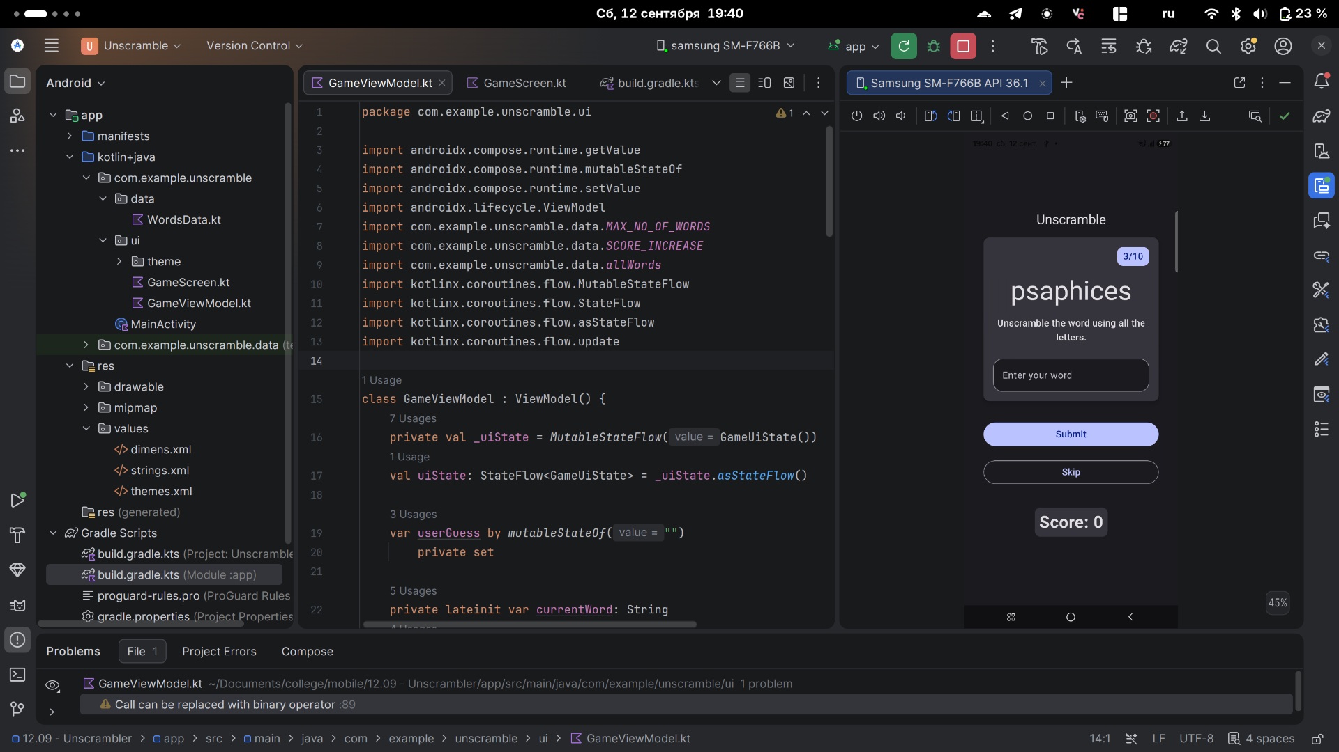
GameViewModel.kt

package com.example.unscramble.ui
import androidx.compose.runtime.getValue
import androidx.compose.runtime.mutableStateOf
import androidx.compose.runtime.setValue
import androidx.lifecycle.ViewModel
import com.example.unscramble.data.MAX_NO_OF_WORDS
import com.example.unscramble.data.SCORE_INCREASE
import com.example.unscramble.data.allWords
import kotlinx.coroutines.flow.MutableStateFlow
import kotlinx.coroutines.flow.StateFlow
import kotlinx.coroutines.flow.asStateFlow
import kotlinx.coroutines.flow.update
class GameViewModel : ViewModel() {
private val _uiState = MutableStateFlow(GameUiState())
val uiState: StateFlow<GameUiState> = _uiState.asStateFlow()
var userGuess by mutableStateOf("")
private set
private lateinit var currentWord: String
private val usedWords = mutableSetOf<String>()
init {
resetGame()
}
fun updateUserGuess(guessedWord: String) {
userGuess = guessedWord
}
fun checkUserGuess() {
if (userGuess.equals(currentWord, ignoreCase = true)) {
val updatedScore = _uiState.value.score.plus(SCORE_INCREASE)
updateGameState(updatedScore)
} else {
_uiState.update { currentState ->
currentState.copy(isGuessedWordWrong = true)
}
}
updateUserGuess("")
}
fun skipWord() {
updateGameState(_uiState.value.score)
updateUserGuess("")
}
private fun updateGameState(updatedScore: Int) {
if (usedWords.size == MAX_NO_OF_WORDS) {
_uiState.update { currentState ->
currentState.copy(
isGuessedWordWrong = false,
score = updatedScore,
isGameOver = true
)
}
} else {
_uiState.update { currentState ->
currentState.copy(
isGuessedWordWrong = false,
currentScrambledWord = pickRandomWordAndShuffle(),
currentWordCount = currentState.currentWordCount.inc(),
score = updatedScore
)
}
}
}
fun resetGame() {
usedWords.clear()
_uiState.value = GameUiState(currentScrambledWord = pickRandomWordAndShuffle())
}
private fun pickRandomWordAndShuffle(): String {
currentWord = allWords.random()
if (usedWords.contains(currentWord)) {
return pickRandomWordAndShuffle()
} else {
usedWords.add(currentWord)
}
return shuffleCurrentWord(currentWord)
}
private fun shuffleCurrentWord(word: String): String {
val tempWord = word.toCharArray()
tempWord.shuffle()
while (String(tempWord).equals(word)) {
tempWord.shuffle()
}
return String(tempWord)
}
}
data class GameUiState(
val currentScrambledWord: String = "",
val currentWordCount: Int = 1,
val score: Int = 0,
val isGuessedWordWrong: Boolean = false,
val isGameOver: Boolean = false
)

GameScreen.kt

/*
* Copyright (C) 2023 The Android Open Source Project
*
* Licensed under the Apache License, Version 2.0 (the "License");
* you may not use this file except in compliance with the License.
* You may obtain a copy of the License at
*
* https://www.apache.org/licenses/LICENSE-2.0
*
* Unless required by applicable law or agreed to in writing, software
* distributed under the License is distributed on an "AS IS" BASIS,
* WITHOUT WARRANTIES OR CONDITIONS OF ANY KIND, either express or implied.
* See the License for the specific language governing permissions and
* limitations under the License.
*/
package com.example.unscramble.ui
import android.app.Activity
import androidx.compose.foundation.background
import androidx.compose.foundation.layout.Arrangement
import androidx.compose.foundation.layout.Column
import androidx.compose.foundation.layout.fillMaxWidth
import androidx.compose.foundation.layout.padding
import androidx.compose.foundation.layout.safeDrawingPadding
import androidx.compose.foundation.layout.statusBarsPadding
import androidx.compose.foundation.layout.wrapContentHeight
import androidx.compose.foundation.rememberScrollState
import androidx.compose.foundation.text.KeyboardActions
import androidx.compose.foundation.text.KeyboardOptions
import androidx.compose.foundation.verticalScroll
import androidx.compose.material3.AlertDialog
import androidx.compose.material3.Button
import androidx.compose.material3.Card
import androidx.compose.material3.CardDefaults
import androidx.compose.material3.MaterialTheme.colorScheme
import androidx.compose.material3.MaterialTheme.shapes
import androidx.compose.material3.MaterialTheme.typography
import androidx.compose.material3.OutlinedButton
import androidx.compose.material3.OutlinedTextField
import androidx.compose.material3.Text
import androidx.compose.material3.TextButton
import androidx.compose.material3.TextFieldDefaults
import androidx.compose.runtime.Composable
import androidx.compose.ui.Alignment
import androidx.compose.ui.Modifier
import androidx.compose.ui.draw.clip
import androidx.compose.ui.platform.LocalContext
import androidx.compose.ui.res.dimensionResource
import androidx.compose.ui.res.stringResource
import androidx.compose.ui.text.input.ImeAction
import androidx.compose.ui.text.style.TextAlign
import androidx.compose.ui.tooling.preview.Preview
import androidx.compose.ui.unit.dp
import androidx.compose.ui.unit.sp
import com.example.unscramble.R
import com.example.unscramble.ui.theme.UnscrambleTheme
import androidx.lifecycle.viewmodel.compose.viewModel
import androidx.compose.runtime.collectAsState
import androidx.compose.runtime.getValue
import androidx.compose.material3.OutlinedTextFieldDefaults
@Composable
fun GameScreen(
gameViewModel: GameViewModel = viewModel()
) {
val gameUiState by gameViewModel.uiState.collectAsState()
val mediumPadding = dimensionResource(R.dimen.padding_medium)
Column(
modifier = Modifier
.verticalScroll(rememberScrollState())
.padding(mediumPadding),
verticalArrangement = Arrangement.Center,
horizontalAlignment = Alignment.CenterHorizontally
) {
Text(
text = stringResource(R.string.app_name),
style = typography.titleLarge,
)
GameLayout(
onUserGuessChanged = { gameViewModel.updateUserGuess(it) },
onKeyboardDone = { gameViewModel.checkUserGuess() },
userGuess = gameViewModel.userGuess,
wordCount = gameUiState.currentWordCount,
currentScrambledWord = gameUiState.currentScrambledWord,
isGuessWrong = gameUiState.isGuessedWordWrong,
modifier = Modifier
.fillMaxWidth()
.wrapContentHeight()
.padding(mediumPadding)
)
Column(
modifier = Modifier
.fillMaxWidth()
.padding(mediumPadding),
verticalArrangement = Arrangement.spacedBy(mediumPadding),
horizontalAlignment = Alignment.CenterHorizontally
) {
Button(
modifier = Modifier.fillMaxWidth(),
onClick = { gameViewModel.checkUserGuess() }
) {
Text(
text = stringResource(R.string.submit),
fontSize = 16.sp
)
}
OutlinedButton(
onClick = { gameViewModel.skipWord() },
modifier = Modifier.fillMaxWidth()
) {
Text(
text = stringResource(R.string.skip),
fontSize = 16.sp
)
}
}
GameStatus(score = gameUiState.score, modifier = Modifier.padding(20.dp))
}
if (gameUiState.isGameOver) {
FinalScoreDialog(
score = gameUiState.score,
onPlayAgain = { gameViewModel.resetGame() }
)
}
}
@Composable
fun GameLayout(
onUserGuessChanged: (String) -> Unit,
onKeyboardDone: () -> Unit,
userGuess: String,
wordCount: Int,
currentScrambledWord: String,
isGuessWrong: Boolean,
modifier: Modifier = Modifier
) {
val mediumPadding = dimensionResource(R.dimen.padding_medium)
Card(
modifier = modifier,
elevation = CardDefaults.cardElevation(defaultElevation = 5.dp)
) {
Column(
verticalArrangement = Arrangement.spacedBy(mediumPadding),
horizontalAlignment = Alignment.CenterHorizontally,
modifier = Modifier.padding(mediumPadding)
) {
Text(
modifier = Modifier
.clip(shapes.medium)
.background(colorScheme.surfaceTint)
.padding(horizontal = 10.dp, vertical = 4.dp)
.align(alignment = Alignment.End),
text = stringResource(R.string.word_count, wordCount),
style = typography.titleMedium,
color = colorScheme.onPrimary
)
Text(
text = currentScrambledWord,
style = typography.displayMedium
)
Text(
text = stringResource(R.string.instructions),
textAlign = TextAlign.Center,
style = typography.titleMedium
)
OutlinedTextField(
value = userGuess,
singleLine = true,
shape = shapes.large,
modifier = Modifier.fillMaxWidth(),
colors = OutlinedTextFieldDefaults.colors(
focusedContainerColor = colorScheme.surface,
unfocusedContainerColor = colorScheme.surface,
disabledContainerColor = colorScheme.surface
),
onValueChange = onUserGuessChanged,
label = {
if (isGuessWrong) {
Text(stringResource(R.string.wrong_guess))
} else {
Text(stringResource(R.string.enter_your_word))
}
},
isError = isGuessWrong,
keyboardOptions = KeyboardOptions.Default.copy(
imeAction = ImeAction.Done
),
keyboardActions = KeyboardActions(
onDone = { onKeyboardDone() }
)
)
}
}
}
@Composable
private fun FinalScoreDialog(
score: Int,
onPlayAgain: () -> Unit,
modifier: Modifier = Modifier
) {
val activity = (LocalContext.current as Activity)
AlertDialog(
onDismissRequest = { },
title = { Text(text = stringResource(R.string.congratulations)) },
text = { Text(text = stringResource(R.string.you_scored, score)) },
modifier = modifier,
dismissButton = {
TextButton(
onClick = { activity.finish() }
) {
Text(text = stringResource(R.string.exit))
}
},
confirmButton = {
TextButton(onClick = onPlayAgain) {
Text(text = stringResource(R.string.play_again))
}
}
)
}
@Composable
fun GameStatus(score: Int, modifier: Modifier = Modifier) {
Card(
modifier = modifier
) {
Text(
text = stringResource(R.string.score, score),
style = typography.headlineMedium,
modifier = Modifier.padding(8.dp)
)
}
}
@Preview(showBackground = true)
@Composable
fun GameScreenPreview() {
UnscrambleTheme {
GameScreen()
}
}

